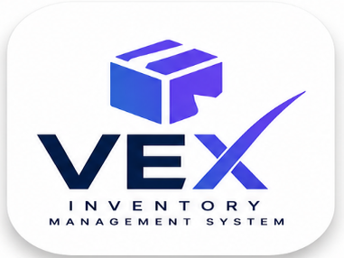

vexbrandfamily@gmail.com

Bill to:
(Account Name)
(Contacts)
(Country)
(Account Email)

INVOICE

Invoice number VEX-x(Assign 5 no. in place of x)
Invoice date (Current Date)
Due date (3 Days from Current Date)
Amount due (As per Calculations)

Description | Quantity | Rate (excl. tax) | Tax | Amount (excl. tax)
mm dd – mm dd, yyyy
Account Name | (Per the Quantity) | $0.01344 |  | (Product of Quanitu and rate)
Discount |  |  |  | -$10.00

Egress GB  mm dd – mm dd, yyyy |  |  | 0% | $0.02
Account Name |  |  |  | $0.02
Discount (-250 units) |  |  |  | -$0.02
Monthly Active Users  mm dd – mm dd, yyyy | 1 | $0.00325 | 0% | $0.02
Pro Plan  mm dd – mm dd, yyyy | 1 | $20.00 | 16% | $20.00

Subtotal (Total obtained from the above calculations)
Amount due (Net total of the above amounts)

Memo:
Prices are exclusive of applicable taxes unless stated otherwise. Where VEX Inventory Management System is registered for sales tax, VAT, GST, or equivalent, it has been charged on this invoice based on your billing address. For Kenyan invoices, the listed price is GST-inclusive.

For B2B sales into jurisdictions where reverse charge applies, the customer is responsible for accounting for VAT/ GST to their local tax authority under the reverse charge mechanism.

